Domain-Specific Lexicon

What is Domain-Specific Lexicon
# Source: AI Source: Provided by: [Data Path: Persons Table -> ID Column: 1, Name_En Column: Motasem Essam] -> From: [Chatgpt (GPT-4-turbo)] on [7/29/2025]
A Domain-Specific Lexicon is a lexicon that contains words, phrases, and terminologies specific to a particular subject area or professional field. These lexicons are essential for ensuring clarity, precision, and effective communication within specialized disciplines.

🔹 Key Features of a Domain-Specific Lexicon
# Source: AI Source: Provided by: [Data Path: Persons Table -> ID Column: 1, Name_En Column: Motasem Essam] -> From: [Chatgpt (GPT-4-turbo)] on [7/29/2025]
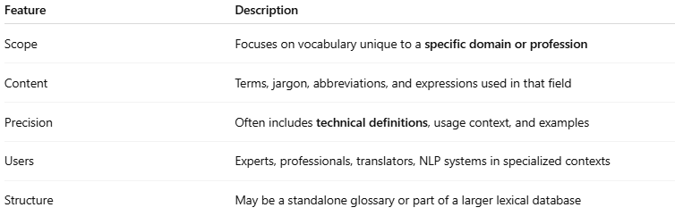
Feature | Description
Scope | Focuses on vocabulary unique to a specific domain or profession
Content | Terms, jargon, abbreviations, and expressions used in that field
Precision | Often includes technical definitions, usage context, and examples
Users | Experts, professionals, translators, NLP systems in specialized contexts
Structure | May be a standalone glossary or part of a larger lexical database

🔹 Examples of Domain-Specific Lexicons
# Source: AI Source: Provided by: [Data Path: Persons Table -> ID Column: 1, Name_En Column: Motasem Essam] -> From: [Chatgpt (GPT-4-turbo)] on [7/29/2025]
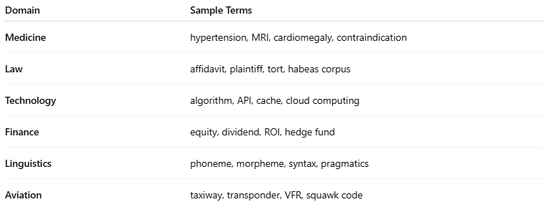
Domain | Sample Terms
Medicine | hypertension, MRI, cardiomegaly, contraindication
Law | affidavit, plaintiff, tort, habeas corpus
Technology | algorithm, API, cache, cloud computing
Finance | equity, dividend, ROI, hedge fund
Linguistics | phoneme, morpheme, syntax, pragmatics
Aviation | taxiway, transponder, VFR, squawk code

🔹 Purposes and Applications
# Source: AI Source: Provided by: [Data Path: Persons Table -> ID Column: 1, Name_En Column: Motasem Essam] -> From: [Chatgpt (GPT-4-turbo)] on [7/29/2025]
- Technical communication (manuals, research papers)
- Translation/localization (e.g., in legal or medical contexts)
- Domain-specific NLP (e.g., medical chatbots, legal document analysis)
- Education and training (specialized vocabulary lists)
- Ontology development (e.g., SNOMED CT in medicine)

🔹 Domain-Specific Lexicon vs General Lexicon
# Source: AI Source: Provided by: [Data Path: Persons Table -> ID Column: 1, Name_En Column: Motasem Essam] -> From: [Chatgpt (GPT-4-turbo)] on [7/29/2025]
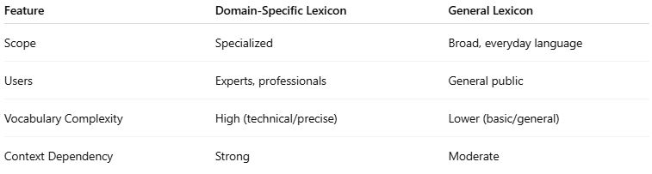
Feature | Domain-Specific Lexicon | General Lexicon
Scope | Specialized | Broad, everyday language
Users | Experts, professionals | General public
Vocabulary Complexity | High (technical/precise) | Lower (basic/general)
Context Dependency | Strong | Moderate

